SKILL WEEK-4 : TRIGGERS AND PROCEDURES(V.SATHVIK,2520090097)

------------------------------------------------------------

PROCEDURE TO DISPLAY ALL CUSTOMERS
------------------------------------------------------------

DELIMITER //
CREATE PROCEDURE GetAllCustomers() BEGIN
SELECT * FROM Customer; END //

DELIMITER ;

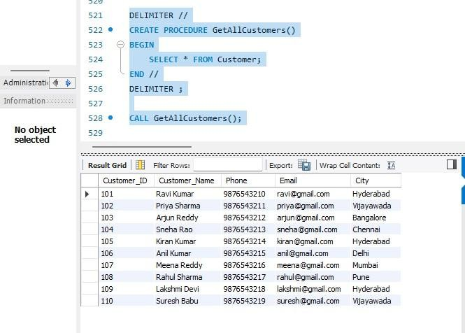
CALL GetAllCustomers();

------------------------------------------------------------

PROCEDURE TO DISPLAY ACCOUNT DETAILS FOR A GIVEN ACCOUNT NUMBER
------------------------------------------------------------

DELIMITER //
CREATE PROCEDURE GetAccountDetails( IN p_Account_No INT

) BEGIN
SELECT *

FROM Account
WHERE Account_No = p_Account_No; END //

DELIMITER ;

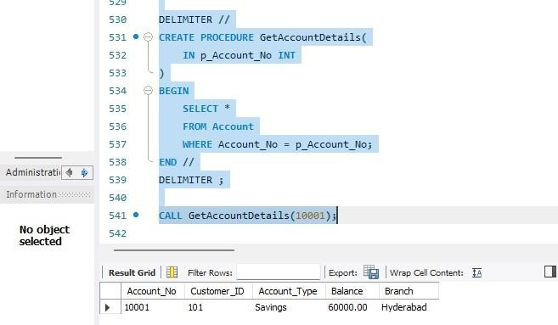
CALL GetAccountDetails(10001);

PROCEDURE TO FIND CUSTOMER ACCOUNTS
------------------------------------------------------------

DELIMITER //
CREATE PROCEDURE GetCustomerAccounts( IN p_Customer_ID INT

) BEGIN

SELECT
C.Customer_ID, C.Customer_Name, A.Account_No, A.Account_Type, A.Balance, A.Branch
FROM Customer C JOIN Account A
ON C.Customer_ID = A.Customer_ID WHERE C.Customer_ID = p_Customer_ID;

END //

DELIMITER ;

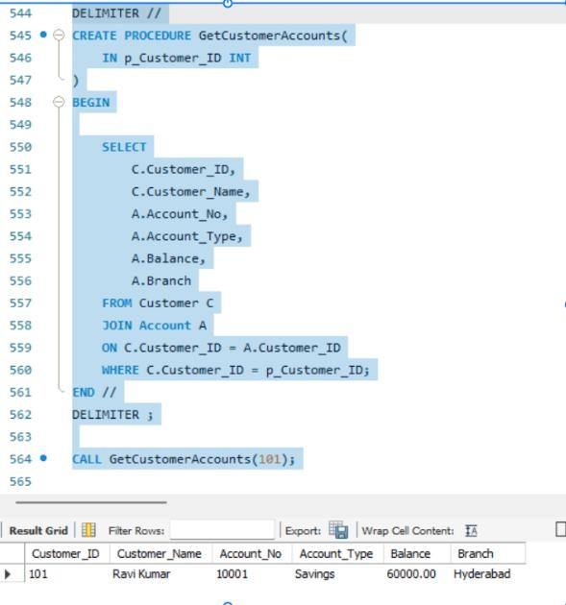
CALL GetCustomerAccounts(101);
------------------------------------------------------------

PROCEDURE TO DEPOSIT MONEY
------------------------------------------------------------

DELIMITER //
CREATE PROCEDURE DepositMoney( IN p_Account_No INT,
IN p_Amount DECIMAL(12,2)

) BEGIN
UPDATE Account
SET Balance = Balance + p_Amount WHERE Account_No = p_Account_No;

END // DELIMITER ;

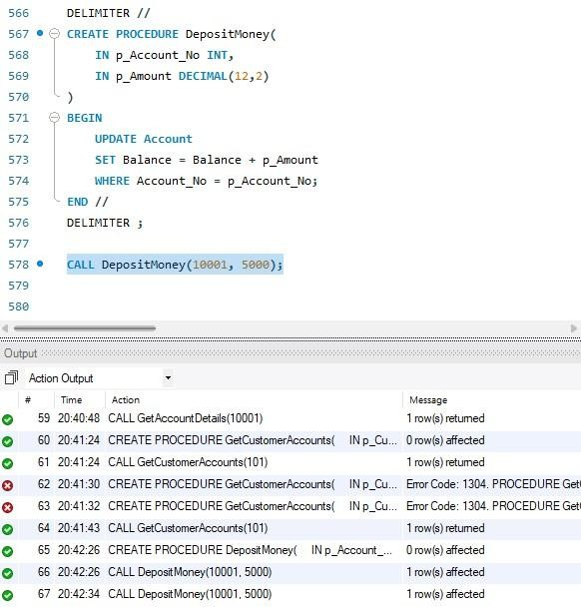
CALL DepositMoney(10001, 5000);

------------------------------------------------------------

PROCEDURE TO WITHDRAW MONEY
------------------------------------------------------------

DELIMITER //
CREATE PROCEDURE WithdrawMoney( IN p_Account_No INT,
IN p_Amount DECIMAL(12,2)

) BEGIN
UPDATE Account
SET Balance = Balance - p_Amount WHERE Account_No = p_Account_No;

END // DELIMITER ;

CALL WithdrawMoney(10001, 3000);

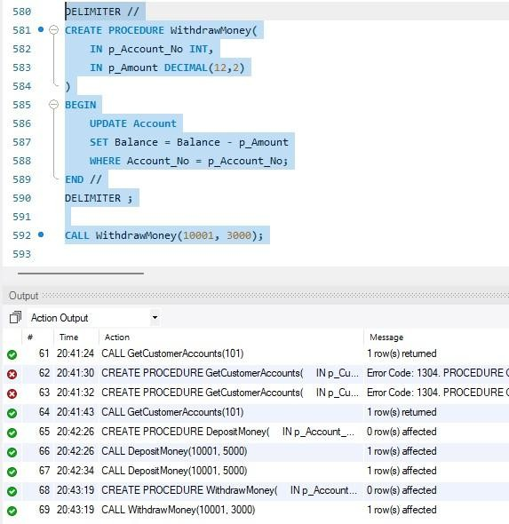

===========================

TRIGGERS
===========================
------------------------------------------------------------

TRIGGER – PREVENT NEGATIVE BALANCE
------------------------------------------------------------

DELIMITER //
CREATE TRIGGER CheckBalance BEFORE UPDATE ON Account FOR EACH ROW

BEGIN
IF NEW.Balance < 0 THEN

SIGNAL SQLSTATE '45000' SET MESSAGE_TEXT =
'Transaction failed: Insufficient balance'; END IF;

END // DELIMITER ;

UPDATE Account
SET Balance = Balance - 60000 WHERE Account_No = 10001;
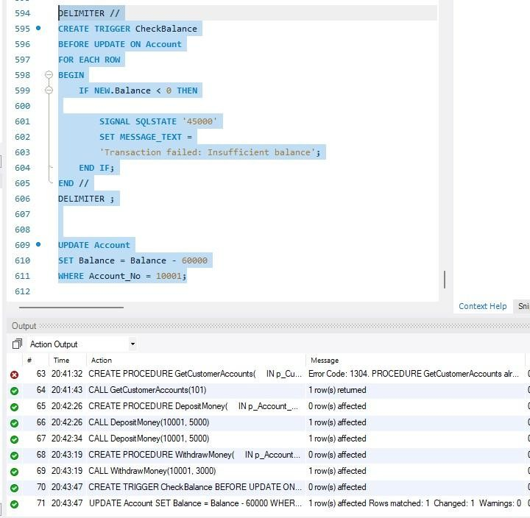

----------------------------------------------------------

TRIGGER – PREVENT NEGATIVE DEPOSIT
------------------------------------------------------------

DELIMITER //
CREATE TRIGGER CheckTransactionAmount BEFORE INSERT ON Bank_Transaction

FOR EACH ROW BEGIN
IF NEW.Amount <= 0 THEN

SIGNAL SQLSTATE '45000' SET MESSAGE_TEXT =
'Transaction amount must be greater than zero'; END IF;

END // DELIMITER ;

INSERT INTO Bank_Transaction (Account_No, Transaction_Type, Amount) VALUES

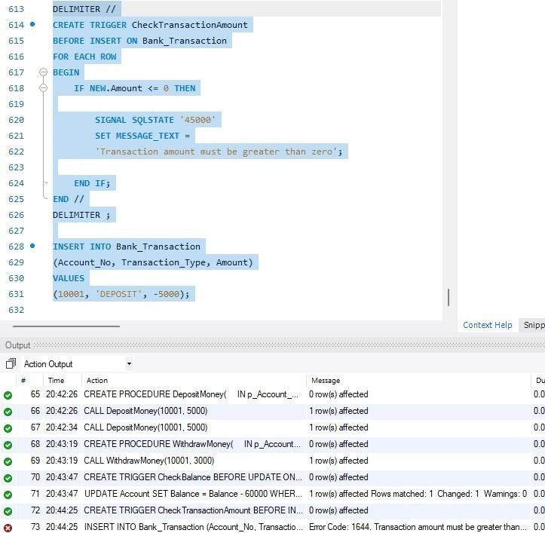
(10001, 'DEPOSIT', -5000);

------------------------------------------------------------

CREATE TRANSACTION AUDIT TABLE
------------------------------------------------------------
CREATE TABLE Transaction_Audit (
Audit_ID INT PRIMARY KEY AUTO_INCREMENT,
Transaction_ID INT, Account_No INT,
Transaction_Type VARCHAR(20), Amount DECIMAL(12,2),
Audit_Date DATETIME DEFAULT CURRENT_TIMESTAMP
);

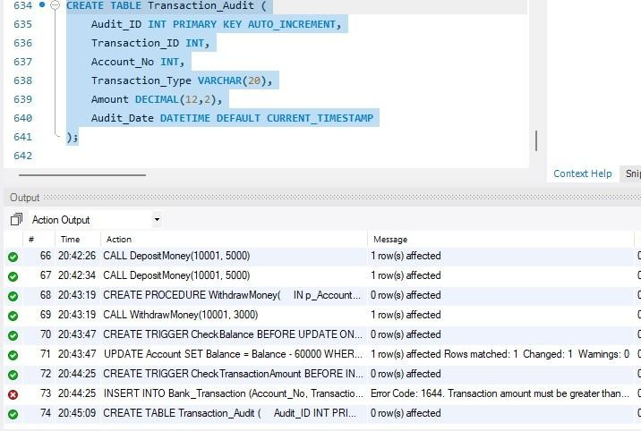

------------------------------------------------------------

TRIGGER – TRANSACTION AUDIT
------------------------------------------------------------

DELIMITER //
CREATE TRIGGER TransactionAudit AFTER INSERT ON Bank_Transaction FOR EACH ROW

BEGIN

INSERT INTO Transaction_Audit (
Transaction_ID, Account_No, Transaction_Type, Amount
)

VALUES (
NEW.Transaction_ID, NEW.Account_No, NEW.Transaction_Type, NEW.Amount
);

END // DELIMITER ;

INSERT INTO Bank_Transaction (Account_No, Transaction_Type, Amount) VALUES

(10001, 'DEPOSIT', 2500);

SELECT * FROM Transaction_Audit;
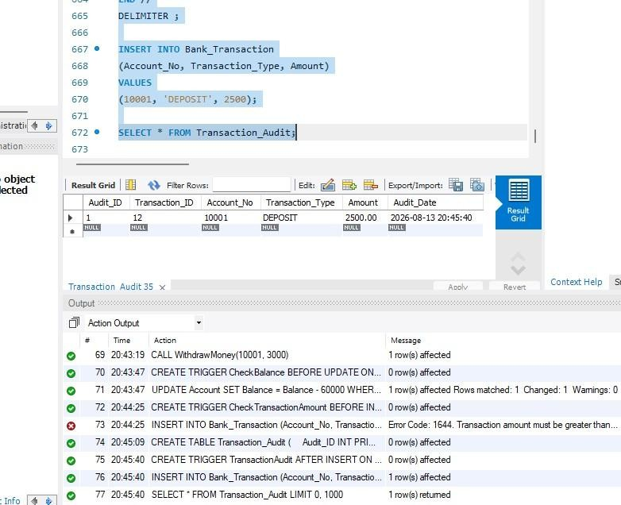

------------------------------------------------------------

TRIGGER – AUTOMATICALLY UPDATE ACCOUNT BALANCE
------------------------------------------------------------

DELIMITER //
CREATE TRIGGER UpdateBalanceAfterTransaction AFTER INSERT ON Bank_Transaction

FOR EACH ROW BEGIN
IF NEW.Transaction_Type = 'DEPOSIT' THEN UPDATE Account
SET Balance = Balance + NEW.Amount WHERE Account_No = NEW.Account_No;

ELSEIF NEW.Transaction_Type = 'WITHDRAW' THEN UPDATE Account
SET Balance = Balance - NEW.Amount WHERE Account_No = NEW.Account_No;

END IF;
END // DELIMITER ;

INSERT INTO Bank_Transaction (Account_No, Transaction_Type, Amount) VALUES

(10001, 'DEPOSIT', 5000);

SELECT *
FROM Account
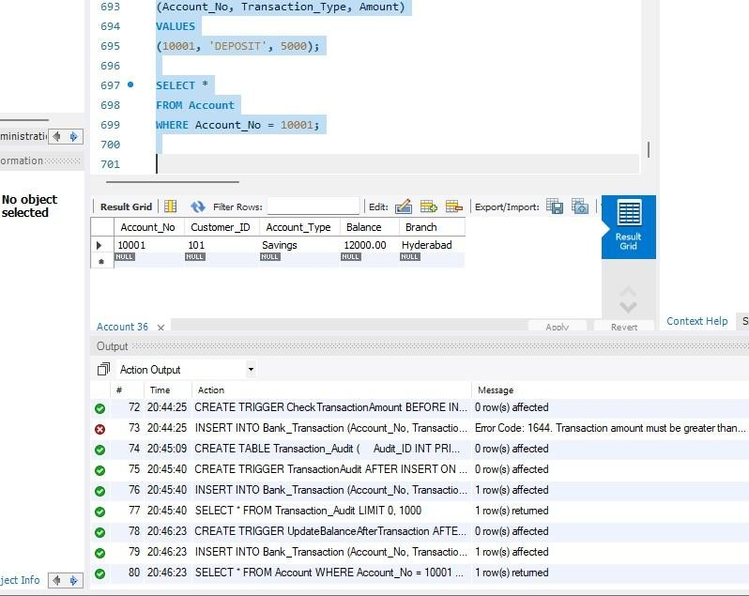
WHERE Account_No = 10001;

------------------------------------------------------------

TRIGGER – PREVENT WITHDRAWAL ABOVE BALANCE
------------------------------------------------------------

DELIMITER //
CREATE TRIGGER PreventInsufficientWithdrawal BEFORE INSERT ON Bank_Transaction

FOR EACH ROW BEGIN
DECLARE CurrentBalance DECIMAL(12,2); SELECT Balance
INTO CurrentBalance
FROM Account
WHERE Account_No = NEW.Account_No;

IF NEW.Transaction_Type = 'WITHDRAW' AND NEW.Amount > CurrentBalance THEN

SIGNAL SQLSTATE '45000' SET MESSAGE_TEXT =
'Withdrawal failed: Insufficient balance'; END IF;

END // DELIMITER ;

INSERT INTO Bank_Transaction (Account_No, Transaction_Type, Amount) VALUES

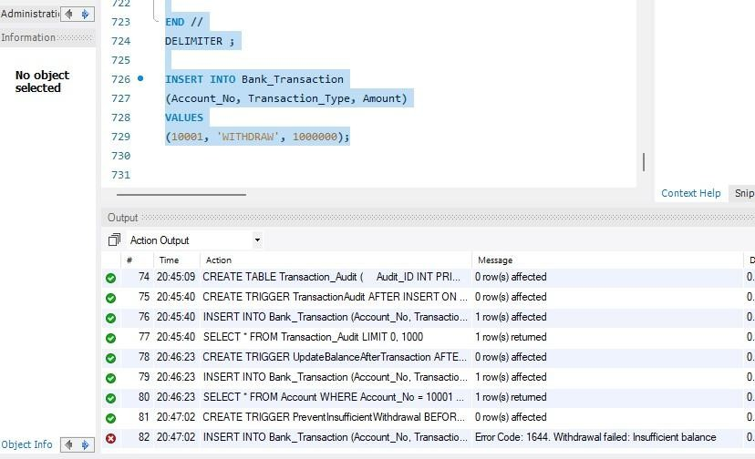
(10001, 'WITHDRAW', 1000000);
============================================================ ADVANCED STORED PROCEDURES

============================================================
------------------------------------------------------------

PROCEDURE – ACCOUNT TRANSFER
------------------------------------------------------------

DELIMITER //
CREATE PROCEDURE TransferMoney( IN SenderAccount INT,
IN ReceiverAccount INT,
IN TransferAmount DECIMAL(12,2)

) BEGIN
DECLARE SenderBalance DECIMAL(12,2); SELECT Balance
INTO SenderBalance
FROM Account
WHERE Account_No = SenderAccount;
IF SenderBalance < TransferAmount THEN SIGNAL SQLSTATE '45000'
SET MESSAGE_TEXT =
'Transfer failed: Insufficient balance'; ELSE
UPDATE Account
SET Balance = Balance - TransferAmount WHERE Account_No = SenderAccount;

UPDATE Account
SET Balance = Balance + TransferAmount WHERE Account_No = ReceiverAccount;

END IF;

END // DELIMITER ;

CALL TransferMoney(10001, 10002, 5000);

SELECT *
FROM Account
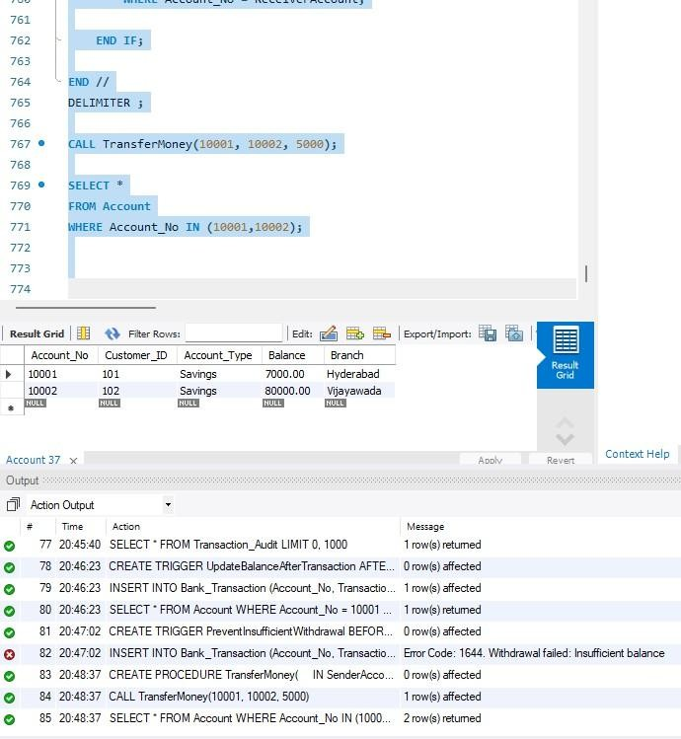
WHERE Account_No IN (10001,10002);

------------------------------------------------------------

PROCEDURE – CUSTOMER LOAN DETAILS
------------------------------------------------------------

DELIMITER //

CREATE PROCEDURE GetCustomerLoans( IN p_Customer_ID INT

) BEGIN

SELECT
C.Customer_Name, L.Loan_ID,

L.Loan_Type, L.Loan_Amount, L.Interest_Rate
FROM Customer C JOIN Loan L
ON C.Customer_ID = L.Customer_ID WHERE C.Customer_ID = p_Customer_ID;

END // DELIMITER ;

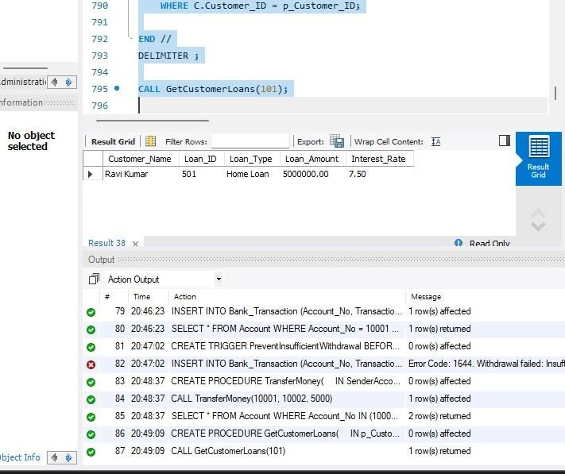
CALL GetCustomerLoans(101);

------------------------------------------------------------

PROCEDURE – HIGH BALANCE ACCOUNTS
------------------------------------------------------------

DELIMITER //
CREATE PROCEDURE HighBalanceAccounts( IN MinimumBalance DECIMAL(12,2)

) BEGIN

SELECT *
FROM Account

WHERE Balance >= MinimumBalance ORDER BY Balance DESC;

END // DELIMITER ;
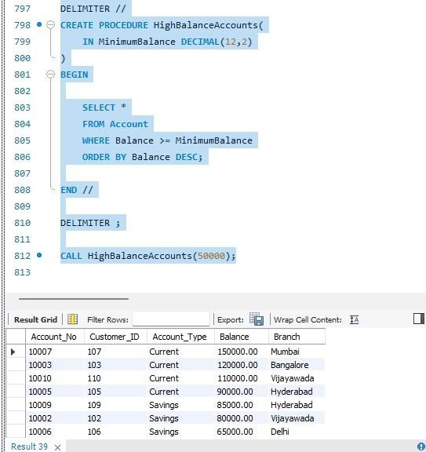
CALL HighBalanceAccounts(50000);

PROCEDURE WITH IN, OUT PARAMETERS
------------------------------------------------------------

DELIMITER //

CREATE PROCEDURE GetBalance( IN p_Account_No INT,
OUT p_Balance DECIMAL(12,2)

) BEGIN

SELECT Balance INTO p_Balance FROM Account
WHERE Account_No = p_Account_No; END //

DELIMITER ;

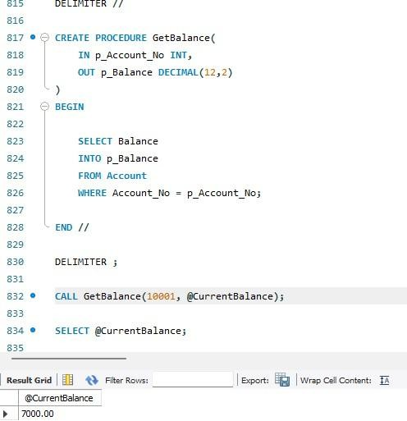
CALL GetBalance(10001, @CurrentBalance); SELECT @CurrentBalance;

============================================================ TRIGGER MANAGEMENT COMMANDS
============================================================

SHOW TRIGGERS;

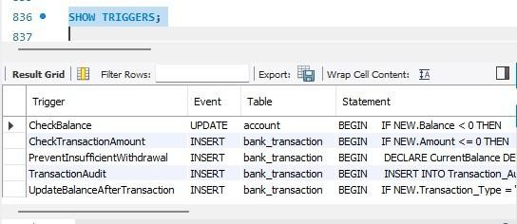

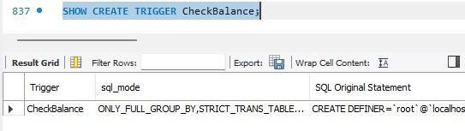
SHOW CREATE TRIGGER CheckBalance;

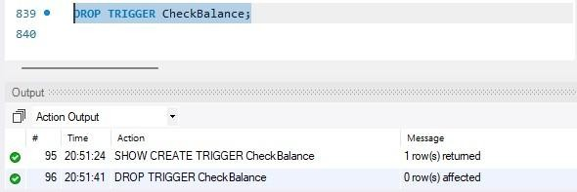
DROP TRIGGER CheckBalance;

============================================================ PROCEDURE MANAGEMENT COMMANDS

============================================================ SHOW PROCEDURE STATUS
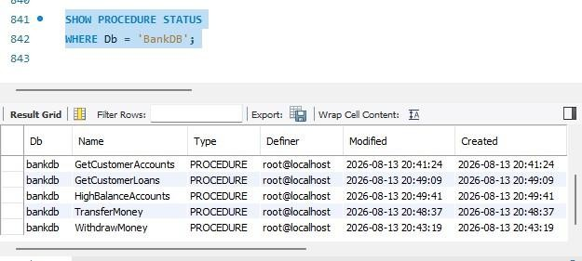
WHERE Db = 'BankDB';

